Hands-on: Intro to qGIS and two Tutorials

The goal of this hands-on activity is to be familiar with one of the leading technologies on geographic information system (GIS), qGIS.

## Spatio-temporal GIS data

**Spatio-temporal GIS data** sets are hot in currency and bear **crucial insights for public good**, however, these are complex structures when dealing with analytical tools and visual analytics. The power of software and friendly interface is desired. ArcGIS is the leader in the enterprise field, qGIS is doing almost the same job in the open source platforms.

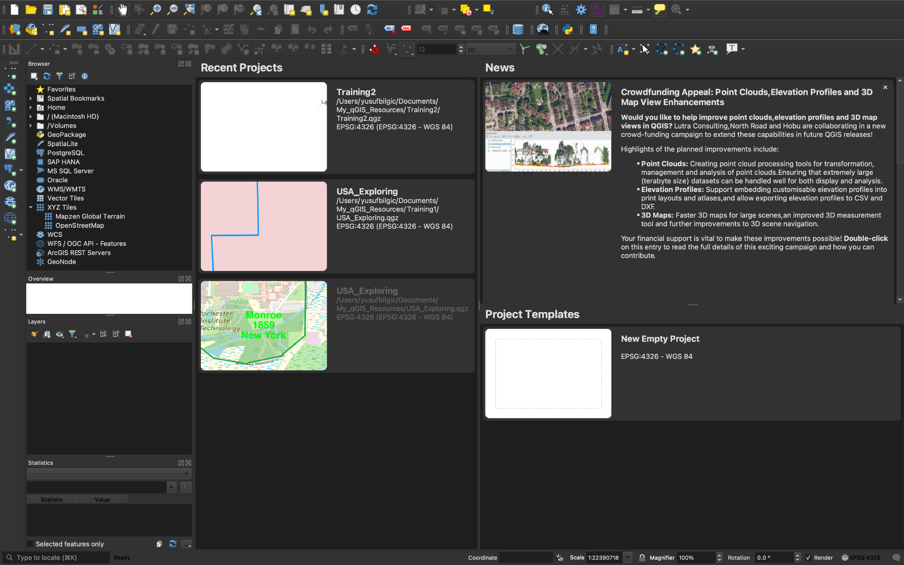

Our preference is qGIS (q means Quantum) in dealing with Spatio-temporal GIS data: it is a free and open-source cross-platform desktop geographic information system application that supports viewing, editing, printing, and analysis of geospatial data.

qGIS functions as geographic information system (GIS) software, allowing users to analyze and edit spatial information, in addition to composing and exporting graphical maps.

qGIS supports **raster, vector and mesh layers**.

## Some terms

* **A mesh** is an unstructured grid usually with temporal and other components. The spatial component contains a collection of vertices, edges and faces in 2D or 3D space: vertices - XY(Z) points (in the layer's coordinate reference system) edges - connect pairs of vertices.
* **Meshes** include a matrix of vertices and a matrix of indices. The simplest kind of mesh is a basic **raster**.
* **Vector data** represents geographic data symbolized as points, lines, or polygons. **Raster data** represents geographic data as a matrix of cells that each contains an attribute value. While the area of different polygon shapes in a data set can differ, each cell in a raster data set is the same cell.
* **Vector data** is stored as either point, line, or polygon features.
* The **vector model** uses points and line segments to identify locations on the earth while the **raster model** uses a series of cells to represent locations on the earth. The figure represents vector (left) versus raster (right) data. One of the most common types of raster data is land cover derived from satellite imagery.
* **Raster images** are compiled using pixels, or tiny dots, containing unique color and tonal information that come together to create the image. Since raster images are pixel based, they are resolution dependent.
* **Raster images** are best for digital photos and print materials. If your project requires scalable shapes and solid colors, vector is the best choice, but if your project requires complex color blends, raster is the preferred format.

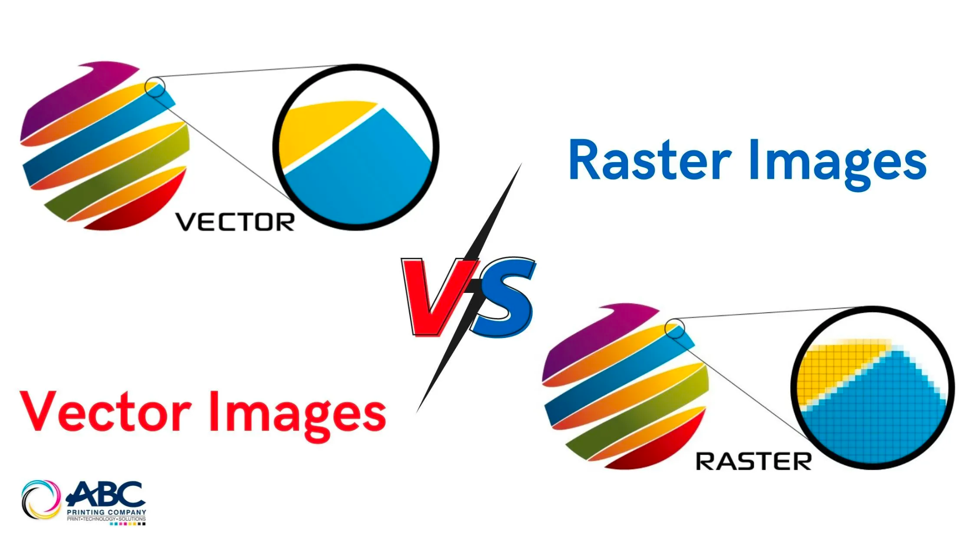

## What the qGIS software can do

Get some ideas what the qGIS software can do:

* Visit <https://www.qgis.org/en/site/about/screenshots.html> for examples.
* Visit case studies <https://www.qgis.org/en/site/about/case_studies/index.html#>.
* Visit the campus map case study <https://www.qgis.org/en/site/about/case_studies/australia_distance_learning.html>.

## Installation and Two Intro Videos

Now, do these three followings:

1. First, [download](https://www.qgis.org/en/site/forusers/download.html) and install the qGIS. In case some issues pop up, visit [here](https://courses.spatialthoughts.com/install-qgis-ltr.html).
   1. Most stable version is QGIS 3.28 LTR. I recommend this version
   2. Try QGIS 3.30
2. First, watch the [Intro to qGIS Instructor Video](https://rit.zoom.us/rec/share/AcsPoHI68dtaWPb2vTnSddlIDL-2-sQa9fyO13sx767AYoZSEIxiAFTgHFtAg3PS.0kW3r2d00udzkWaH?startTime=1666545224000). This is just a general intro to qGIS.
3. Watch and practice the first 30 min of the introductory [tutorial video](https://youtu.be/d15Xl4OphDk). You can use USA>Rochester>RIT main campus area or your own choice like home country while practicing it. The data can be found at [here](https://www.diva-gis.org/gData).

## Your practice

Now, choose and complete **any two** of the tutorials in your interest below:

1. **Basic Vector Styling** [here](https://www.qgistutorials.com/en/docs/3/basic_vector_styling.html).
2. **Line and Statistics** [here](https://www.qgistutorials.com/en/docs/3/calculating_line_lengths.html).
3. **Animating Time Series** data [here](https://www.qgistutorials.com/en/docs/3/animating_time_series.html).
4. **Network Visualization and Routing** [here](https://www.qgistutorials.com/en/docs/3/basic_network_analysis.html).
5. **Travel Time Analysis with Uber Movement** [here](https://www.qgistutorials.com/en/docs/3/travel_time_analysis.html).

## Submission

Once you have completed the two tutorials in your interest, **post the screenshots** (one best shot for each tutorial) of your qGIS work on Discussions>Hands-on qGIS.

**Then you are done with the tutorials!**

## Advanced - Python Integration

The QGIS Python Console window can be accessed by using **the Python Console item in the Plugins menu**. When you select this command, the Python Console will appear in the lower-right corner of the QGIS window.

QGIS provides a Python API (Application Programming Interface), commonly known as **PyQGIS**. The API is vast and very capable. Almost every operation that you can do using QGIS - can be done using the API. This allows developers to write code to build new tools, customize the interface and automate workflows. Visit <https://courses.spatialthoughts.com/pyqgis-in-a-day.html> for more info.

You can automate QGIS with Python:

* Using the QGIS Python console.
* Using the QGIS Python editor.
* Using PyQGIS to manipulate the QGIS interface.
* Using PyQGIS to manipulate a layers symbology.
* Using PyQGIS to manipulate a layer's attributes.
* Using PyQGIS to manipulate a layer's geometry.
* Using PyQGIS to perform spatial operations.

This advanced portion is optional for the students who want to learn more and employ in the final project.